CIS 572 Object Oriented System Design

Assignment 1 (Part 1) - ChocoAn Charter and ERD

|  |  |  |  |
| --- | --- | --- | --- |
| **VersionNumber** | **Date** | **Revision Author** | **Description of Revision** |
| 1 | 06/11/2019 | She-Wolverine | Updated ERD |
| 2 | 7/7/2019 | Second Run | Updated Document |

# Table of Contents

Problem Statement 2

Current State 3

Future State 4

Complete Entity Relationship Diagram 5

Entity Diagrams 6

# **Problem Statement**

Many people are addicted to chocolates. They eat too much ~~of~~ chocolate in different forms which may lead to weight gain and other health issues. Most of them would like to quit the habit of eating chocolates but they cannot do it themselves and may need external support and guidance from healthcare professionals. To address this issue Chocoholics Anonymous formed an organization which would have professional healthcare providers like dieticians, internists and exercise specialists. All these professionals can work together and address the chocolate addiction issue faced by a member.

To make the functioning of the business easier, ChocAn has a terminal which allows providers to look up for the services that they can provide and ~~also~~ their costs are displayed on the screen. Providers can guide the members on which service would better suit them according to the kind of addiction they have. Members can swipe the card or enter their member number to receive the services. ~~While providers~~ ~~a~~After providing the services to the members, ~~they~~ providers can again swipe the members card, enter member details, provider details, service details and bill the ~~c~~ChocAn. Providers can gather weekly bills and ChocAn will make payment to the provider based on the services and number of services that each provider had served for a ~~particular~~ given week. Member will receive details about the weekly services they received and ~~also~~ the total cost of the services rendered. Similarly, the provider will receive the reports about weekly services and weekly fee details. ChocAn provides flexibility to modify the members/provider details and ~~also~~ would delete them from the system if they are no longer part of ChocAn. Managers can view the accounts Payable. ChocAn has third party vendors like Bank and ACME which handles Money transfers to Providers, ~~and~~ handles the membership fees, and statuses respectively. Additionally, ChocAn can verify the member details from the ChocAn Data center before providing services.

# **Current State**

Chocoholics Anonymous (ChocAn) dedicated themselves to helping people who are addicted to chocolate.ChocAn helps addicted people by providing them with the health providers who can be dietitians, Internists or exercise experts. Members will have to register and pay a monthly fee to chocAn to receive unlimited services. ChocAn will pay providers for the total consultations and services they provide each week. ~~The providers provide different services to the members and ChocAn will be paying to the providers according to the number of consultations and type of service they provide.~~

Operators at ChocAn can add, modify and delete the members or providers records. Members are required to register at ChocAn. After Registration at ChocAn, Member will be provided with a card that will have a Member number. If the Member does not pay monthly fee at least for over a month from the due date, then the member status will be showed in the system as suspended. Healthcare provider will also be given with a provider number. When a member has to receive a service, the member number has to be entered in the terminal or the health card needs to be swiped.

The current system doesn’t state whether ChocAn will retain the records for a certain period of time or permanently delete them from ChocAn records, when the member or provider details are deleted from the system. Saving the details can help reassigning the member or provider to the ChocAn. To make the payment easy, ChocAn can propose the auto payment processing to the system.

ChocAn data center validates the member based on the member number and provides the status as “Validated”. If the number is incorrect then the status displayed is “Invalid Number”.

The System maintains a directory with service name, service code and the associated price. System allows the provider to calculate the total bill~~s~~ for the services provided on a weekly basis. Through EFT, bank transfers the amount into the providers bank account. A third party agency named ACME manages the membership fee details, to change the status to suspend and to reinstate the suspended member.

Manager can pull summary report. Members will also get a report on list of services that they received from ChocAn via email. Provider will also get a report on list of services they provided for a week via email.

ChocAn doesn’t provide any additional benefits to the loyal members. To further extend the business and attract members rewards points can be proposed and members can utilize the reward points and redeem services. Additionally ChocAn can store the progress of ~~the~~ each member and track their progress. This can help the member and provider to make timely changes to the member’s health plan/services. ChocAn can provide an interface for the reports so that the manager can have access to account payable at any time.

**Future State**

When the membership fee is paid, the status in the system will be active and validated message will be displayed on the screen. When the member doesn’t pay membership fee on time then the member status will be changed to suspended. The System will keep the data of the deleted or suspended members or providers, it will be convenient to trace back the clients that ChocAn has served till date and who ChocAn served and also when they want to join back. This feature will make the re-registration process much quicker. Operators will be able to look at the deleted members or suspended members and change their status to Active. Changes will be made accordingly in ChocAn data center, ACME and EFT.

ChocAn will provide each member with rewards points if they pay monthly fees on time. The members who are loyal customers of ChocAn can redeem those points for any kind of service from ChocAn or they can even redeem those points for next month membership fee. System will store the reward points and redemption details of the members. System will show that a limit of 200 reward points will be needed to redeem the points. Rewards data will be stored in the data center and will also reflect on the terminal when the member’s card is swiped. Operator can share the reward point details with each member whenever they ask for.

ChocAn provides the member with auto payment option and save the credit card details of the members so that monthly fee payment will not become a hassle for them. They can opt out of auto payment at any point of time. ChocAn can save details about auto payment status of each member in the system. When the operators logs into the system, operator can set this option for the member. For the auto payment option, each member has to share his or her credit card details and billing address. These details will be saved in the ChocAn Data Center~~Database~~ and also, these details will be shared with the ACME, which manages the membership fee and the member status.

ChocAn system tracks the progress and shares the progress chart with the member via text message or email. Progress chart will have the upcoming appointments, status, progress on health services, account balance and reward points. The progress will have different messages based on the health services that a member is receiving from a ChocAn provider. Based on the progress, provider will suggest the member either to continue with the same treatment/service or suggest a new service which may lower the member’s chocolate addiction further. This helps ChocAn to provide best services to the member.

ChocAn Terminal provides interface for the reports where reports can be viewed directly instead of sending them via email. Access is provided to the manager to view customer, provider reports along with summary reports. ChocAn provides an interface for manager where he can click on different buttons/links to view summary reports, customer reports and provider reports instantaneously. This ensures that manager have full information about what is going in the organization.

# **Complete Entity Relationship Diagram**

# 

# **Entity Diagrams**

1. Provider

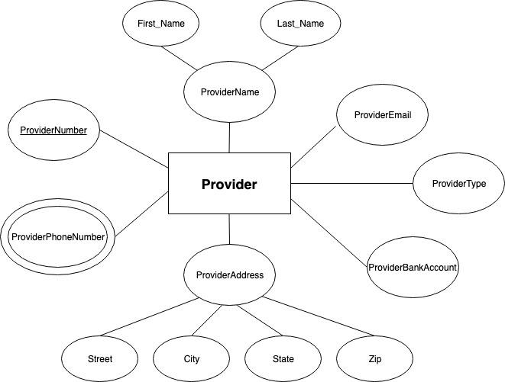

1. Member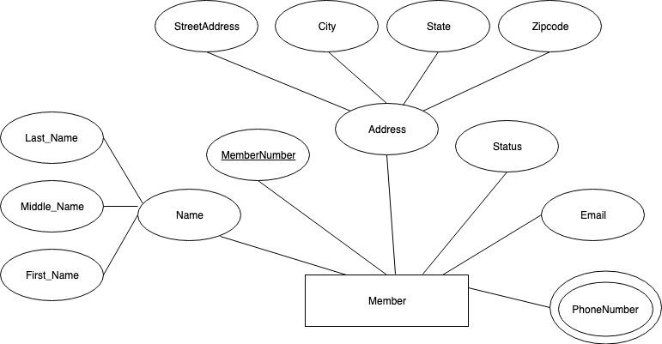
2. Service

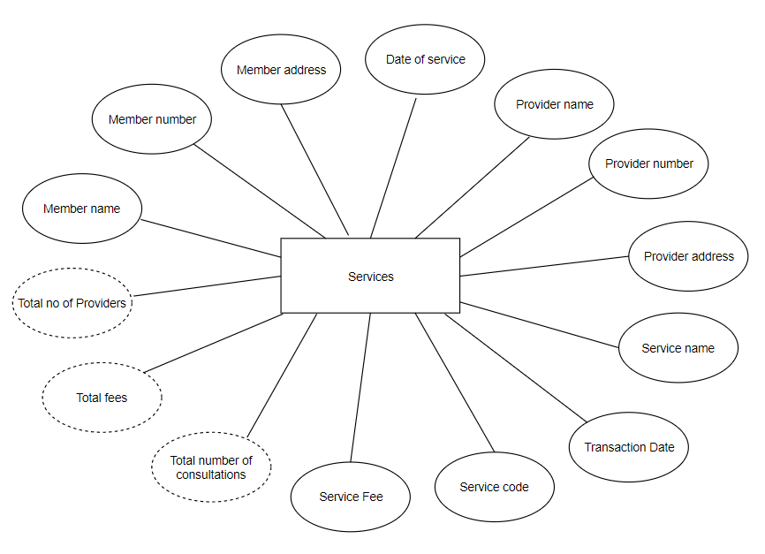

1. Member Card

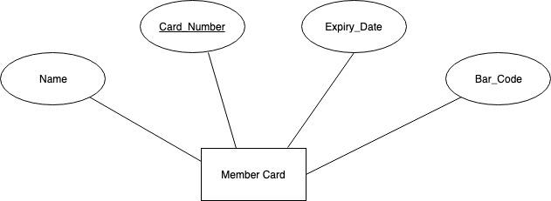

1. Provider Directory

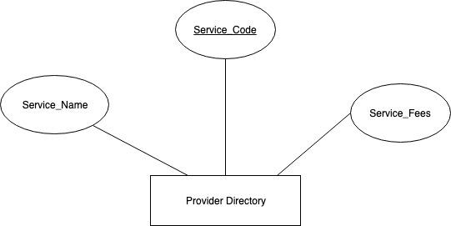

1. ChocoAn Employee

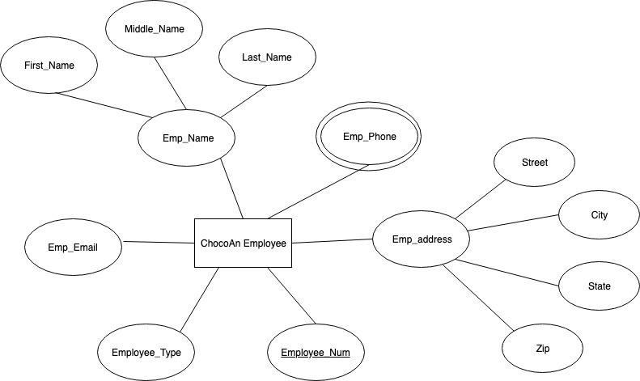

1. EFT

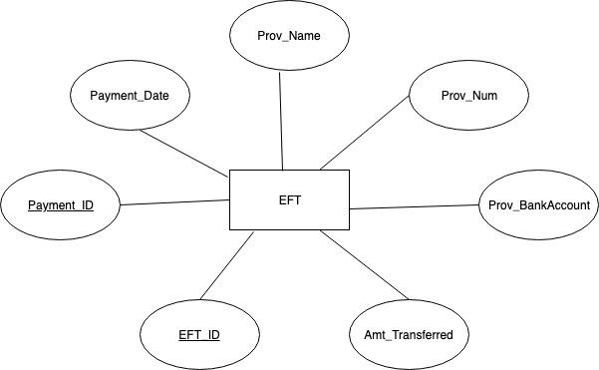

1. AAS (Acme Accounting Services)

